***HUNZA VALLEY TOURS***

Nestled within the embrace of the Karakoram Range in Northern Pakistan, Hunza Valley stands as a pristine sanctuary of natural wonder. Majestic peaks, Rakaposhi and Ultar Sar, encircle this paradise, offering vistas that leave visitors in awe. The Hunza River, adorned with turquoise clarity, meanders through, adding to the allure of the landscape. Verdant terraced fields, fruit-laden orchards, and vibrant blooms create an idyllic panorama. The genial hospitality of the Hunza people, renowned for their longevity and vibrant traditions, further enchants the valley. Embrace the unique dances, melodies, and culture of the region. Hunza’s fame stems from its apricot groves, earning it the moniker “Land of Apricot Blossoms,” a spectacle of pink during spring. The Baltit Fort, a UNESCO Heritage Site, stands as a testament to the area’s history and architectural marvels. Exploring the fort offers a portal to the past and vistas of the valley. Hunza, a Launchpad for journeys to Altit Fort, Attabad Lake, and Hoper Glacier, offers serenity, crisp mountain air, and a rendezvous with the Karakoram’s grandeur, rendering it an irresistible haven for nature enthusiasts and adventure aficionados.

### Itinerary

**Day 01:  
Arrival Islamabad**

Upon your arrival at Islamabad airport, we extend a warm welcome and transfer you to your hotel. Our day of exploration in the beautiful city of Islamabad begins with a visit to the Lok Virsa Museum. Here, you’ll have the opportunity to immerse yourself in the rich cultural tapestry of Pakistan, gaining insights into its diverse heritage. Our journey continues to Daman-e-Koh, a scenic viewpoint that promises breathtaking panoramic views of the city. The serene atmosphere and the stunning vistas provide an ideal setting to appreciate the city’s landscape. Next on our itinerary is the Japanese Garden, a tranquil haven where you can enjoy the peaceful surroundings and beautiful landscapes. This spot offers a delightful escape, allowing you to unwind amidst nature. We then proceed to Shakarparian, a park known for its lush greenery and pleasant walking paths. This is an excellent place to take leisurely strolls, surrounded by the beauty of nature. Our day concludes with a visit to Rawal Dam, a picturesque reservoir where you can relax and revel in the natural beauty. The calm waters and scenic surroundings provide a perfect backdrop for relaxation. As the day unfolds, you’ll have the opportunity to explore the cultural, scenic, and recreational facets of Islamabad, making it a day filled with diverse experiences and enjoyable moments. Overnight Islamabad.

**Day 02:  
Islamabad – Besham**

[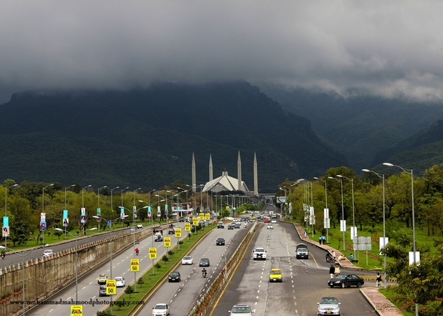](https://www.pakistantours.pk/wp-content/uploads/2017/07/islamabad-pakistan.jpg)

Our day begins with an early start as we set out on a scenic drive towards Besham. The route takes us through notable cities like Haripur, Abbottabad, and Mansehra, offering glimpses of their local culture and landscapes. A significant highlight of our journey is a visit to Taxila, a UNESCO World Heritage site renowned for its archaeological significance. As an ancient center of learning and a vital hub of the Gandhara civilization, Taxila unveils layers of history and cultural heritage. Exploring the well-preserved ruins and artifacts, we gain valuable insights into the ancient civilizations that once thrived in this region. Resuming our journey on the iconic Karakoram Highway, we follow the majestic River Indus, a constant companion on our route. Along the way, we make picturesque stops at Batagram, capturing the beauty of the surroundings through memorable photographs. As our day unfolds, we gradually approach Besham, a town known for its strategic location along the Karakoram Highway. Upon reaching Besham, we settle into our hotel, offering a comfortable and relaxing stay. This day not only provides a blend of historical exploration in Taxila but also allows us to appreciate the natural beauty of the region as we traverse the Karakoram Highway. Overnight Besham.

**Day 03:  
Besham – Gilgit**

Our journey continues as we leave Besham behind and set our course for the captivating city of Gilgit. Along the way, the road unfolds before us, revealing remarkable sights and natural wonders. Our first stop is the Nanga Parbat Viewpoint, offering a breathtaking perspective of the majestic Nanga Parbat, one of the world’s highest peaks. The panoramic views of this iconic mountain create a sense of awe and appreciation for the grandeur of nature. As we drive further, we are treated to a spectacular confluence of three mighty mountain ranges—the Karakoram, Himalaya, and Hindu Kush. This convergence creates a breathtaking panorama, showcasing the diverse and awe-inspiring landscapes that define this region. The journey also includes witnessing the confluence of the Gilgit River merging into the Indus River. This natural phenomenon adds a touch of wonder to our adventure, as we observe the meeting of these two significant rivers. The Karakoram Highway, our path to Gilgit, is adorned with rock carvings, showcasing the ancient art and heritage of the region. These intricate carvings provide a glimpse into the rich cultural history that has shaped the landscapes we traverse. Finally, we reach Gilgit, a vibrant city surrounded by stunning natural beauty. As we settle in for the night, we have the opportunity to immerse ourselves in the charm of Gilgit and reflect on the awe-inspiring sights and cultural richness encountered along the way. Overnight Gilgit.

**Day 04:  
Gilgit – Hunza Valley**

[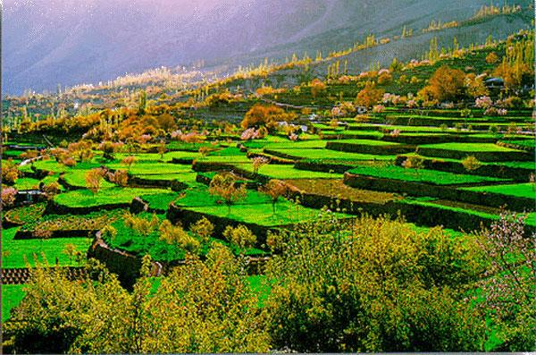](https://www.pakistantours.pk/wp-content/uploads/2017/07/Hunza.jpg)

Embarking on the road to the mesmerizing Hunza Valley, our journey unfolds alongside the picturesque Hunza River, offering glimpses of its pristine beauty. A notable stop along the way is the Rakaposhi viewpoint, a vantage point that grants us the opportunity to marvel at the grandeur of Rakaposhi Peak. This majestic mountain stands tall, commanding attention with its snow-capped peaks and awe-inspiring presence. Continuing our scenic drive, we eventually reach Karimabad, the capital of the Hunza Valley. Nestled amid the breathtaking landscapes, Karimabad welcomes us with its serene charm and cultural richness. As we check into our hotel, we immerse ourselves in the tranquility and beauty that define this enchanting valley. Karimabad, with its historical significance, carries echoes of the past as a vital stop on the historic Silk Route. This ancient trade route played a crucial role in facilitating cultural exchange and commerce between different civilizations. The remnants of this historical legacy add depth to our exploration of Karimabad. This day unfolds as a perfect blend of natural wonders, highlighted by the majestic Rakaposhi Peak, and a journey into the historical significance of the Silk Route, providing a holistic and enriching travel experience. Overnight Karimabad.

**Day 05:  
Hunza Valley Sightseeing**

Embarking on a new day of exploration, we set our course for the mesmerizing Hoper Glacier, a natural wonder surrounded by renowned peaks such as Ultar, Hunza Dome, Bublimating, Spantik, and Diran. The majestic presence of these towering peaks creates a breathtaking backdrop to the picturesque town of Karimabad, with the dominating Rakaposhi Peak standing tall at 7,788 meters. As we journey towards the Hoper Glacier, the scenery unfolds with unparalleled beauty, offering panoramic views of the surrounding peaks and the glacier’s serene expanse. This adventure provides a unique opportunity to witness the grandeur of the Karakoram Range and its pristine landscapes. Returning to Karimabad, our exploration continues with a visit to the Baltit Fort Museum. Here, we delve into the rich history and culture of the region, immersing ourselves in the artifacts and exhibits that narrate the tales of Hunza’s past. The Baltit Fort stands as an architectural marvel, reflecting the cultural heritage and resilience of the Hunza people. Our journey through history and heritage extends to the Altit Fort, another gem that showcases the architectural prowess and cultural significance of Hunza. Exploring the corridors and chambers of this ancient fort, we gain insights into the traditions and way of life that have shaped the Hunza Valley over the centuries. As the day comes to a close, we return to Hunza Karimabad, surrounded by the awe-inspiring peaks of Ganash and other towering mountains. The tranquil night in Hunza allows us to reflect on the day’s adventures and the profound beauty that defines this region. Overnight Karimabad.

**Day 06:  
Hunza Valley – Khunjerab Pass**

[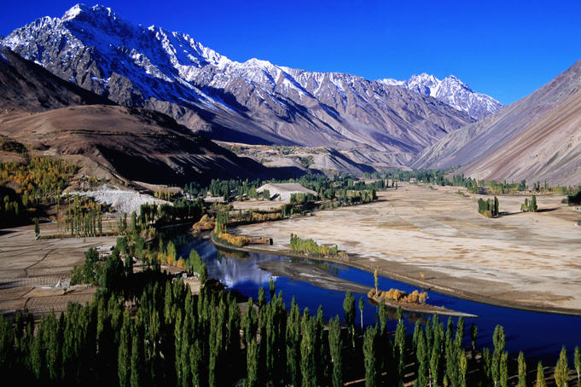](https://www.pakistantours.pk/wp-content/uploads/2017/07/Gilgit-Baltistan-Pakistan.jpg)

Embark on a thrilling excursion to Khunjerab Pass, the highest point on the Karakoram Highway, reaching an elevation of 4,734 meters. This journey promises an unforgettable experience, weaving through charming villages, captivating landscapes, and cultural riches. Traversing through the picturesque villages of Gulmit, Passu, and Sost, you immerse yourself in their enchanting charm and cultural vibrancy. These settlements offer a glimpse into the local way of life, adorned with traditional architecture and warm hospitality. The awe-inspiring landscapes unfold before your eyes as you ascend towards Khunjerab Pass. Towering peaks, rugged mountains, and expansive valleys create a breathtaking panorama, reminding you of the grandeur of the Karakoram Range. Marvel at the mesmerizing Attabad Lake, renowned for its sparkling blue waters that reflect the surrounding mountains. The lake’s serene beauty leaves a lasting impression, inviting contemplation amidst nature’s splendors. Crossing the iconic Hussiani Bridge becomes an exhilarating feat, spanning the mighty Hunza River. The bridge offers not only a physical passage but also a symbolic transition, connecting you with the rich cultural and geographical tapestry of the region. Returning to Karimabad, you carry cherished memories of Khunjerab Pass, the quaint villages of Passu and Gulmit, the stunning Attabad Lake, and the thrilling Hussiani Bridge. Reflecting on the profound beauty and significance of this remarkable journey, you are left with a sense of awe and wonder, having experienced the unique blend of nature, culture, and adventure in the heart of the Karakoram. Overnight Karimabad.

**Day 07:  
Karimabad – Besham**

Continuing our journey towards Besham, we are embraced by the majestic Indus River, a lifeline that has shaped the history and culture of the region. As we follow the course of the Indus, one of Asia’s longest rivers, we are granted passage through a landscape of profound beauty and historical significance. The Karakoram Highway (KKH), an engineering marvel, unfolds before us, carving its way through the rugged terrain. This highway, often referred to as the Eighth Wonder of the World, not only connects regions but serves as a testament to human ingenuity in the face of challenging landscapes. It provides us with a gateway to adventure and exploration. The panoramic views along the KKH are nothing short of breathtaking. Towering mountains stand as sentinels, watching over verdant valleys and rugged terrain. The untamed beauty of the surroundings becomes a canvas painted with the hues of nature, reminding us of the vast and diverse landscapes our world possesses. As we traverse the winding roads, we are immersed in the serenity and tranquility of the region. The journey becomes a humbling experience, allowing us to connect with the grandeur of nature. The untamed beauty of the landscape serves as a reminder of the Earth’s inherent majesty, inviting reflection on our place within this vast and awe-inspiring world. Our arrival in Besham marks not just a destination but a continuation of the immersive experience, as we carry with us the memories of the breathtaking landscapes and the enduring spirit of the Indus River. Overnight Besham.

**Day 08:  
Besham – Swat Valley – Peshawar**

Embarking on our journey towards Peshawar, we are privileged to explore the captivating Swat Valley, often hailed as the “Switzerland of the East.” Swat unfolds before us as a treasure trove of rich history, cultural significance, and breathtaking landscapes. This valley has been a witness to the ebb and flow of ancient civilizations, notably the Gandhara civilization. The remnants of this historical legacy are scattered across Swat in the form of archaeological sites and Buddhist relics, bearing testimony to the region’s deep-rooted past. As we traverse through Swat, the landscape paints a picture of serene beauty. Snow-capped mountains stand majestically against the horizon, while lush green meadows and crystal-clear streams enhance the valley’s natural allure. Swat’s picturesque scenery, adorned with blooming orchards and terraced fields, creates a mesmerizing panorama that engages our senses. Beyond its natural splendor, Swat is a repository of vibrant traditions, folklore, and distinct handicrafts. The local communities showcase their artistic skills, providing us with a glimpse into the cultural richness of the valley. The serene environment and tranquil ambiance of Swat offer a perfect setting for relaxation and rejuvenation. Each step in Swat becomes a journey into the heart of history and nature, allowing us to appreciate the cultural legacy and the breathtaking beauty that define this remarkable region. Our visit to Swat is a harmonious blend of heritage and natural wonders, leaving us with a deep appreciation for the diversity that Pakistan has to offer. Overnight Peshawar.

**Day 09:  
Peshawar Sightseeing**

[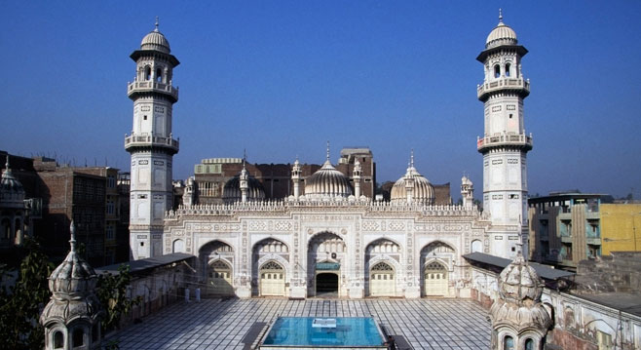](https://www.pakistantours.pk/wp-content/uploads/2017/07/Peshawar.jpg)

Today’s exploration leads us into the heart of Peshawar, a city steeped in cultural and historical significance. Peshawar’s vibrant tapestry unfolds as we delve into its architectural marvels, bustling bazaars, and multicultural heritage. Our journey begins at the iconic Mohabat Khan Mosque, a testament to the region’s rich Islamic heritage. The mosque stands as a majestic architectural masterpiece, adorned with intricate craftsmanship that reflects the artistic excellence of the builders. Its grandeur offers a glimpse into the religious and cultural traditions embedded in Peshawar’s history. Venturing into the lively Kissa Khawani Bazaar, we find ourselves immersed in a historic marketplace teeming with life. The vibrant atmosphere, colorful shops, and the hustle and bustle of street life provide a sensory feast. Here, we have the opportunity to indulge in local flavors, interact with friendly shopkeepers, and partake in the lively trading culture that defines Peshawar. Sethi Street beckons us next, a charming lane flanked by historic buildings that showcase the city’s architectural grandeur. The street serves as a living testament to Peshawar’s rich history, inviting us to stroll through its past and marvel at the structures that have withstood the test of time. Peshawar’s multicultural heritage comes to life as we explore its streets. The city, situated at the crossroads of ancient trade routes, has absorbed influences from Central Asia, Persia, and the Indian subcontinent. This unique blend is reflected in its traditions, folklore, and cuisine. Beyond its architectural and historical treasures, Peshawar invites us to experience the warmth and hospitality of its people. The residents of Peshawar take pride in preserving their cultural heritage, and our exploration of the city allows us to witness this resilience and pride. In Peshawar, every corner reveals a piece of history, and every interaction leaves us with a deeper appreciation for the city’s remarkable past and the living traditions that continue to thrive. Overnight Peshawar.

**Day 10:  
Peshawar – Takht Bhai – Islamabad**

Today’s journey unfolds as we depart from Peshawar, heading towards Islamabad. Along the way, we pause to explore the magnificent Takht Bhai, an ancient Buddhist site, where intricate architecture and historical significance converge. This UNESCO World Heritage site offers a glimpse into the rich tapestry of the region’s past. The memories of our recent Hunza Valley and Karakoram Highway tour are still fresh, with the awe-inspiring landscapes and cultural experiences lingering in our minds. As the road winds its way back to Islamabad, the ever-changing scenery serves as a reflection of Pakistan’s diverse beauty. From the towering peaks of the Karakoram Range to the bustling markets of Peshawar, each element contributes to the vibrant mosaic of the country. Our return journey encapsulates the essence of Pakistan, blending history, culture, and natural wonders into a memorable adventure that will stay with us long after we reach Islamabad.

**Hunza Valley**, located in the Karakoram Range of Northern Pakistan, is indeed a paradise on Earth, captivating visitors with its astounding natural beauty and rich cultural heritage. Here, you’ll find a harmonious blend of awe-inspiring landscapes and warm, vibrant traditions. Let’s further explore the allure of Hunza Valley:

**Ganesh: Sacred Mountain Majesty:** Ganesh is a sacred mountain in the Hunza Valley, revered for its spiritual significance. Towering over the landscape, it adds a mystical aura to the region. The locals believe Ganesh to be home to spiritual beings, and its majestic presence is an integral part of the valley’s cultural and religious heritage.

**Baltit Fort: Timeless Citadel:** As a UNESCO World Heritage Site, the Baltit Fort is a remarkable historical and architectural gem. Exploring this fort allows visitors to delve into the region’s rich history and take in panoramic views of the valley.

**Altit Fort: Historical Marvel:** Altit Fort, alongside Baltit Fort, stands as a testament to the rich history of the Hunza Valley. Dating back over 900 years, Altit Fort is one of the oldest surviving forts in the region. Its architectural grandeur and strategic location offer visitors a glimpse into the valley’s historical evolution, making it a must-visit for history enthusiasts.

**Khunjerab Pass: Roof of the World:** Situated at a breathtaking altitude, Khunjerab Pass is one of the highest paved international border crossings globally, connecting Pakistan and China. The journey to the pass unfolds awe-inspiring views of snow-capped peaks and vast expanses. The unique blend of natural beauty and the sense of crossing into another country makes Khunjerab Pass a memorable experience.

**Hussaini Suspension Bridge:** Daring Crossings: The Hussaini Suspension Bridge is an engineering marvel that spans the Hunza River. Adrenaline rushes as visitors traverse this seemingly fragile yet sturdy bridge, offering spectacular views of the surrounding mountains. The experience is both thrilling and awe-inspiring, making it a highlight for adventure seekers.

**Attabad Lake: Turquoise Gem:** Attabad Lake is a mesmerizing creation of nature, formed after a landslide in 2010. The lake’s striking turquoise waters, surrounded by rugged mountains, create a surreal landscape. Boating on the lake provides a unique perspective of submerged villages and submerged trees, adding a touch of mystery to its beauty.

**Hunza Autumn: Nature’s Canvas:** Hunza transforms into a kaleidoscope of colors during autumn. The valley is adorned with golden hues as the leaves change, creating a breathtaking panorama. The contrast between the azure sky, the golden landscape, and the snow-capped peaks is a photographer’s dream, attracting visitors seeking the serenity of the autumnal palette.

**Rock Carving in Hunza:** Ancient Artistry: The rock carvings in Hunza are a window to the past, showcasing ancient petroglyphs that depict the region’s history and culture. These carvings, found at various sites in the valley, offer insights into the daily lives, rituals, and beliefs of the people who once inhabited this enchanting land.

**Hoper Glacier: Glacial Majesty:** Hoper Glacier is a stunning natural wonder that showcases the raw beauty of ice and rock. Surrounded by jagged peaks, the glacier is a serene destination for trekkers and nature enthusiasts. The crisp mountain air and the panoramic views make Hoper Glacier a tranquil retreat in the heart of the Karakoram Range.

**Passu Cones: Iconic Spires:** The Passu Cones, or Cathedral Spires, are iconic pointed peaks that dominate the Passu village skyline. These unique geological formations are a photographer’s delight, especially during sunrise and sunset when they cast long shadows over the landscape. The Passu Cones are not just mountains; they are natural sculptures, adding to the surreal beauty of Hunza.

**Eagle’s Nest, Hunza:** Panoramic Perch: Eagle’s Nest, perched high above the Hunza Valley, is a vantage point offering panoramic views that seem to touch the heavens. The landscape unfolds beneath, revealing the meandering Hunza River, the majestic mountains, and the quaint villages. It’s not just a viewpoint; it’s an immersive experience, where visitors can witness the valley’s grandeur in all its glory.

**Rakaposhi Peak: Majestic Monolith:** Rakaposhi, with its snow-clad majesty, stands as a sentinel overlooking the Hunza Valley. The second-highest mountain in the Karakoram Range, Rakaposhi’s pyramidal peak captivates all who lay eyes on it. Its aura changes with the shifting light, and its presence defines the skyline, adding an element of grandeur to the Hunza landscape.

**Shimshal Valley: Remote Wonderland:** Shimshal Valley, nestled in the embrace of the Karakoram Range, is a remote wonderland that beckons adventurers. The journey to Shimshal is an odyssey through rocky landscapes and pristine beauty. The valley is a gateway to high-altitude adventures, offering treks to Shimshal Pass and glimpses of traditional Wakhi culture that have thrived in isolation.

**Karimabad: Cultural Nexus:** Karimabad, the main town in the Hunza region, is a cultural nexus where history and modernity intersect. The ancient Baltit and Altit forts stand as guardians of tradition, while the bustling bazaars showcase a blend of local craftsmanship and contemporary life. Karimabad is not just a town; it’s a living testament to the cultural evolution of Hunza.

**Hunza Handicraft: Artisanal Expressions:** Hunza’s handicrafts are artisanal expressions that mirror the valley’s rich cultural tapestry. From intricately woven rugs to vibrant embroidered textiles, each piece tells a story of craftsmanship passed down through generations. Exploring the local markets unveils a treasure trove of Hunza’s artistic heritage, where every creation is a testament to the skill and creativity of the local artisans.

**Hunza Culture: Vibrant Traditions:** Hunza’s culture is a vibrant tapestry woven with traditions that have endured for centuries. The locals, known for their warm hospitality, celebrate life through traditional dances, music, and festivals. Engaging with the community offers a firsthand experience of Hunza’s cultural richness, where every gesture and tradition reflects a deep connection to the land and its people.

**Majestic Scenery:** Nestled amidst towering snow-capped peaks, including the iconic Rakaposhi and Ultar Sar, the valley offers unparalleled panoramic views. The surrounding mountains create a dramatic backdrop for the valley’s pristine beauty.

**Crystal-Clear River:** The Hunza River winds its way through the valley, with its turquoise waters enhancing the overall charm of the region. The river adds to the stunning visuals and provides opportunities for leisurely strolls along its banks.

**Terraced Fields and Orchards:** Lush terraced fields, fruit orchards, and colorful flowers paint a picturesque landscape that changes with the seasons. Spring brings the valley to life with vibrant hues.

**Warm and Welcoming People:** The Hunza people are known for their exceptional longevity, vibrant culture, and welcoming nature. Visitors have the chance to engage with the locals, learn about their traditions, enjoy traditional dances and music, and feel the warmth of Hunza’s hospitality.

**“Land of Apricot Blossoms”:** Hunza’s apricot orchards are famous, and the valley is often referred to as the “Land of Apricot Blossoms.” During spring, the blooming apricot trees create a breathtaking landscape with shades of pink and white.

**Adventure Hub:** Hunza serves as a base for treks to nearby attractions such as the enchanting Altit Fort, the striking Attabad Lake, and the tranquil Hoper Glacier. These natural wonders provide thrilling opportunities for exploration and adventure.

**Tranquil Retreat:** The valley offers a tranquil atmosphere, refreshing mountain air, and awe-inspiring views of the Karakoram Range. It’s a perfect destination for those seeking solace and a connection with nature.

**Culinary Delights:** The Hunza Valley is a treat for the taste buds as well. Local cuisine includes a variety of dishes, often prepared with apricots – from apricot jams and juices to savory dishes. The traditional Hunza bread, locally known as “Chapshuro,” is a must-try, offering a unique and delightful culinary experience.

**Starry Nights:** Away from city lights, the valley offers a celestial spectacle at night. The clear, unpolluted skies make it an ideal spot for stargazing. Visitors can witness the brilliance of the night sky, with countless stars casting a magical glow over the mountains.

**Ancient Trails and Silk Route:** Hunza Valley is steeped in history, and exploring the ancient Silk Route that passed through this region is a journey back in time. The trails are not just paths but stories etched in the landscape, connecting the valley to a bygone era of trade and cultural exchange.

**Local Handicrafts:** The craftsmanship of the Hunza people is reflected in their intricate handicrafts. From handmade rugs and traditional clothing to vibrant jewelry, visitors can take home a piece of Hunza’s culture as a cherished memento.

**Unique Wildlife:** The region boasts diverse wildlife, including the Himalayan ibex and snow leopards. Nature enthusiasts can embark on wildlife tours or engage in bird watching to catch a glimpse of the unique fauna that calls the Hunza Valley home.

**Festivals and Celebrations:** Timing your visit to coincide with local festivals provides a deeper understanding of Hunza’s cultural richness. Festivals like “Jashn-e-Baharan” celebrate the arrival of spring, featuring vibrant parades, traditional dances, and a display of local crafts.

**Spiritual Retreats:** Amidst the stunning landscapes, there are also spiritual retreats and meditation spots where visitors can find serenity. The confluence of nature and spirituality creates a harmonious atmosphere for those seeking moments of reflection and peace.

**Photography Paradise:** For photographers, every corner of Hunza Valley is a canvas waiting to be captured. From the play of light on the mountain peaks to the vibrant hues of apricot blossoms, the valley provides endless opportunities for stunning photographs.

**Discover** Pakistan’s rich heritage and culture through our diverse range of advance reservation tours. From historical and architectural wonders to spiritual and adventurous journeys, we have something for everyone. Explore the enchanting Hunza Valley, follow in the footsteps of legends like Marco Polo, or immerse yourself in the mysticism of Sufi traditions. With options like Heritage & Culture Tours, Karakoram Highway Adventures, and more, unforgettable experiences await. Reserve your spot today and embark on a journey that will create lasting memories.

**Hunza Valley Tours:** Immerse yourself in the enchanting beauty of the Hunza Valley, where majestic mountains and cultural treasures await.

**Lahore Tours:** Explore Lahore’s historical and cultural wonders, from its vibrant streets to its architectural marvels.

**Gandhara Heritage Tours:** Journey through the Gandhara region to discover its rich archaeological heritage and cultural legacy.

**Sikh Pilgrimage Tours:** Embark on a sacred journey to significant Sikh pilgrimage sites, connecting with the spiritual history of the region.

**UNESCO Heritage Site Tour:** Visit UNESCO-listed sites that hold immense cultural and historical significance.

**Mystic Sufi Tours:** Experience the spiritual side of Pakistan with tours that explore Sufi traditions and mysticism.

**Heritage & Culture Tours:** Delve into Pakistan’s cultural tapestry, exploring its heritage sites, art, and local traditions.

**History & Culture Pakistan:** Uncover Pakistan’s fascinating history and cultural diversity through guided tours.

**Archeology & Architecture:** Discover Pakistan’s architectural wonders and ancient archaeological sites with these insightful tours.

**Karakoram Highway Tours:** Traverse the legendary Karakoram Highway, witnessing stunning landscapes and cultural landmarks.

**Alexander Trail Tours:** Follow the footsteps of Alexander the Great on these historical and adventure-filled tours.

**Marco Polo Trail Tours:** Journey along the paths of Marco Polo, exploring the regions he traversed and the cultures he encountered.

**The Great Game Tours:** Experience the intrigue and history of the Great Game era, where geopolitics and exploration converged.

**Men & Mountain Tours:** Embark on daring expeditions that allow you to conquer mountains and forge unforgettable memories.

**Sand & Snow Tours:** Experience the contrast of Pakistan’s landscapes, from deserts to snow-covered peaks.

**Marcoplo Jeep Safari:** Embark on an incredible jeep safari adventure, exploring remote regions and breathtaking vistas.

**Discover Pakistan Tours:** Unveil the hidden gems and diverse landscapes of Pakistan with these comprehensive tours.

**Incredible Jeep Safari:** Immerse yourself in the incredible beauty of Pakistan through thrilling jeep safari excursions.

**Incredible Pakistan Tours:** Discover the awe-inspiring wonders of Pakistan on tours designed to showcase its beauty and diversity.

Whether you’re seeking cultural immersion, historical exploration, adventure, or spiritual experiences, these tours offer a range of options to choose from. Join us on these remarkable journeys and uncover the treasures of Pakistan.